

Creative Work Sample Written Description Timely Shot – Level Mansion Rescue

Yu Zhou

Table of Contents

1. Why Timely Shot? 3

2. Rules & Mechanism 4

a) Key Features 4

i. Rhythm Shooter 4

ii. Blocking 4

b) Rule 4

i. Gameplay & Game Flow 4

ii. Characters Stats & Game Modes 6

c) Enemy AI 6

3. Narrative & Level 7

a) World Setting 7

b) Story Translation to Designs 7

i. Title: 7

ii. Technologies: 7

iii. Rhythm: 7

iv. Operation Base: 7

c) Level Design – Mansion Rescue 8

4. UI & UX 11

a) Crosshair 11

b) Other HUD & Menu 12

5. Art 13

a) Characters 13

i. Player 13

ii. Enemies 13

b) Environment 14

6. Audio 15

a) Music 15

b) Sound Effect 15

7. Future Plan 16

a) Full Game Level Timeline 16

b) Game Modes 17

c) Player Abilities 17

8. Appendixes 18

a) Earliest Test Demo 18

b) Archived One Page Design And Title 18

# Why Timely Shot?

I chose to submit *Timely Shot* as my creative work sample because it represents both my skills and my personal initiative in game design and development. This project began as a spark of inspiration after watching the intense, rhythmic combat scenes in John Wick 4, which left a deep impression on me. When I started formally studying game design last year, I returned to this idea and committed to transforming it into my own game. Timely Shot became my first fully designed game, and I am extremely proud of what it represents.

In *Timely Shot*, I took on multiple roles: game system design, level design, narrative design, interaction design, and guiding the audio and visual elements. From my initial one-page concept to multiple iterations and latest demo, I learned a tremendous amount with each step. I also had the invaluable experiences of working closely with my tutor, Song Huang, as programmer who provided guidance on programming and project structuring; Xinyu Zhang, as 2D artist who studied Visual Communication Design in undergrad and currently pursuing a master degree at China Academy of Art; Shangshu (Mint) Shi, as sound designer and composer, who currently working in Atlanta’s American Gaming Systems. This collaboration with all these talented people, communicating and conveying my designs while assisting them in producing assets, allowed me to refine my design skills and taught me how to communicate effectively across different areas: coding, art, and audio.

*Timely Shot* is not only demonstrating my capabilities as a game designer but also highlighting my ability to collaborate with others, iterate on feedback, and turn a creative vision into a polished product and the translation of my skill from interactive media and motion picture to game designs. This project is a true reflection of my dedication to game design, as it allowed me to push the boundaries of what I could achieve and learn.

Specific Task Distribution:

|  |  |  |
| --- | --- | --- |
| Game Design: Yu Zhou |  | Gameplay programmer: Song Huang |
| Level Design: Yu Zhou |  | Visual Effects: Song Huang |
| Narrative Design: Yu Zhou |  | Sound Engineering: Song Huang, Shangshu Shi |
| Interaction Design: Yu Zhou, Song Huang |  | Sound Design: Yu Zhou, Shangshu Shi |
| UI Design: Yu Zhou |  | Composer: Shangshu Shi |
| Title Design: Yu Zhou, Xinyu Zhang |  | Project Management: Yu Zhou |
| Character Design: Yu Zhou, Xinyu Zhang |  | Game Tester: Lenin Zhou, Lejie Lin, Borui Dong. |
| Character Artist: Xinyu Zhang |  |  |
| Environment Artist: Xinyu Zhang, Yu Zhou |  |  |

# Rules & Mechanism

## Key Features

### Rhythm Shooter

Player can deal higher damage to enemies when the timing of firing match the rhythm of music. When player misses the timing, weapons deal only basic damage; when the timing is good, weapons deal more damage; when timing is perfect, weapons deal maximized damage.

|  |  |  |
| --- | --- | --- |
|  |  |  |
| Bad Timming | Good Timing | Perfect Timming |
|  |  |  |

### Blocking

All weapons are equipped with Kinetic Shield, which captures bullets fired at player and holds for a short amount of time. When a bullet is captured by the shield, players need to react to it by finishing a quick time event to avoid damage. The size of shields, capture force and recharge rate may very base on the weapon equipped.

|  |  |  |
| --- | --- | --- |
|  |  |  |
| Blocking starts | QTE Success | QTE Failed |

## Rule

### Gameplay & Game Flow

Timely Shot is a 2D top-down rhythm shooter game. Player takes on the role of an assassin on a path of revenge, seeking clues to find the murderer of his wife while uncovering a bigger conspiracy behind it.

Player can deal higher damage by shooting in sync with the rhythm, while also paying attention to block incoming bullets. Perfectly matching the rhythm will boost the player's damage, allowing them to finish enemies faster.

Player will start each game with limited health and backup ammunitions. Health can be restored by picking up HP pack, and ammunitions can be restored by picking up Ammo pack. Enemy will drop both HP pack and Ammo Pack when eliminated, these packs can also be found by looting the environment.

|  |  |  |  |
| --- | --- | --- | --- |
|  |  |  |  |
| Enemy Drops | | Environment Loots | |

Game Flow Diagram:

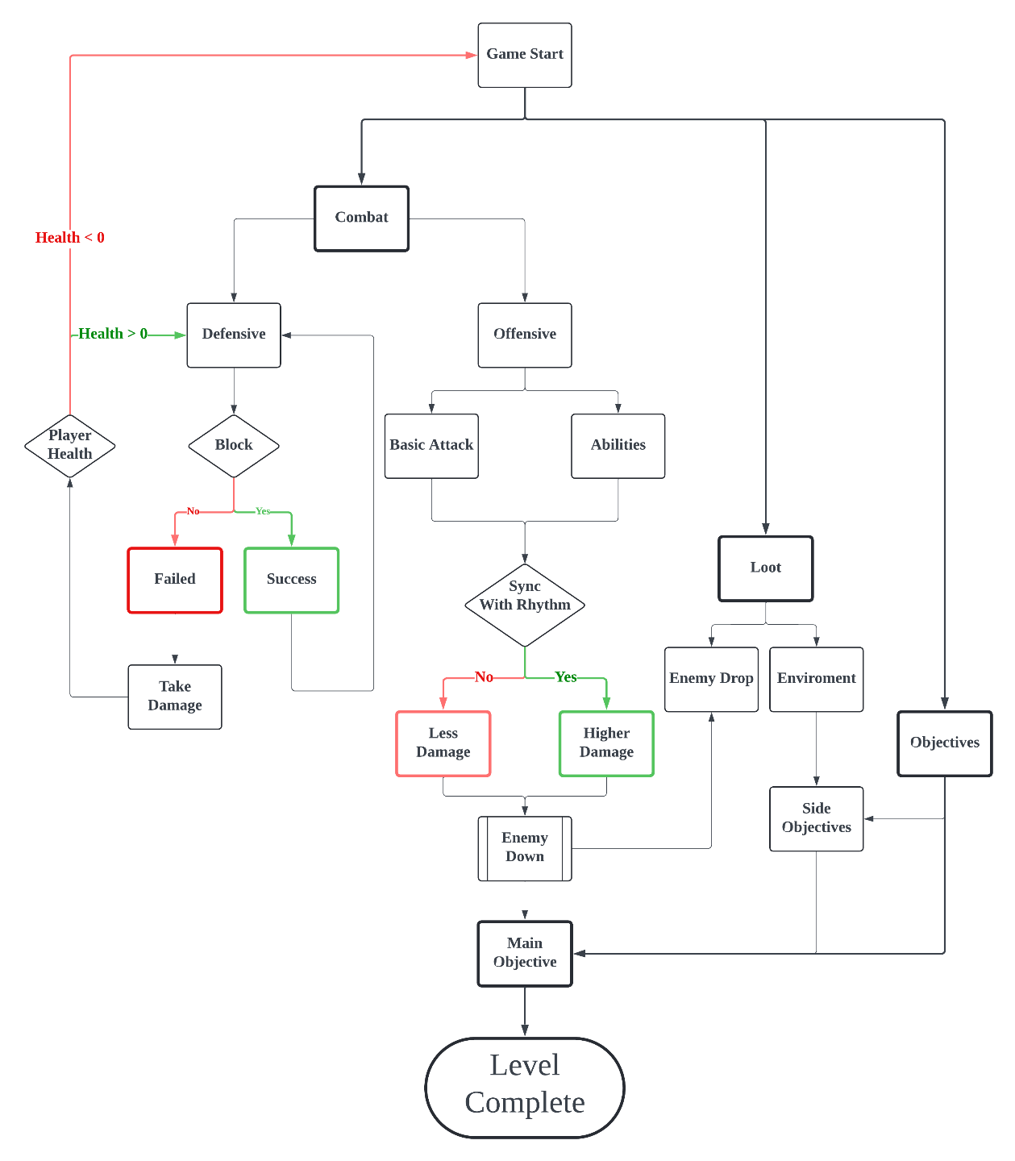

### Characters Stats & Game Modes

Main Character:

|  |  |  |  |  |  |  |  |
| --- | --- | --- | --- | --- | --- | --- | --- |
| **Health** | **Speed** | **Revolver DMG** | **Cap** | **Pistol DMG** | **Cap** | **Shotgun DMG** | **Cap** |
| 20 | 4 | 3/5/7 | 6 | 2/3/5 | 7 | 4/7/10 | 5 |

Enemies:

|  |  |  |  |  |  |
| --- | --- | --- | --- | --- | --- |
| Type | Health | Speed | Weapon | DMG | Characteristics |
| Punk | 5 | 4.5 | Pistol | 2 | Fast movement with low health |
| Guard | 8 | 3.5 | Revolver | 4 | Average enemy |
| Elite | 15 | 3 | Revolver | 4 | Moderate armor. |
| Heavy | 18 | 2 | Shotgun | 8 | Low fire rate but heavy armor. |

Boss: Fixed Base Dual Machine Guns Turret

|  |  |  |  |  |  |  |
| --- | --- | --- | --- | --- | --- | --- |
| **Health -Core** | **Health -**  **Machine Gun** | **Machine Gun DMG** | **CD** | **Electrified Wire**  **DMG** | **CD** | **Punk Spawn Rate** |
| 110 | 60 * 2 | 1 * 7 (burst) | 4 | 4 (per hit) | 7 | Every 6 seconds |

Game Modes:

|  |  |
| --- | --- |
| Modes | Description |
| Raid | A liner level in which provides player a clear one end route to follow and fight. |
| Siege | Player needs to eliminate waves of enemies in a limited space until the countdown ends or retrieve certain objects. |
| Boss | Player faces one or more powerful enemies in a limited space. |

## Enemy AI

|  |  |  |
| --- | --- | --- |
|  |  |  |
| Patrol | Alert & Injured | Seek Cover |
|  |  |  |
|  |  |  |
| Fire Back | Tracing Player | Eliminated & Drop |

# Narrative & Level

## World Setting

J was born in Central America in 2027, where gangs ruled and the government did little. After his parents were killed, he was raised by a mysterious gang. As an adult, he worked as a DJ while doing hitman jobs for the gang. In year of 2052, J met and married W, daughter of the gang`s leader. 2 years later W was shot and died on their wedding anniversary night, J couldn’t cope and disappeared.

Three years later, 2057, old friends Z, the driver, and S, the hacker, found J when J was a total mess. They come with clues of the murderer, persuade J to join them to hunt down the person responsible for W`s death. And their first step is to rescue K, the arsenal keeper, from a heavy guarded mansion.

## Story Translation to Designs

1. Title: The title Timely Shot is not only referring directly to that each shot player fired can deal higher damage by perfect timing, but also the shot as chance and opportunity to block the bullet in time.
2. Technologies: The main storyline is set thirty years in the future—a time that’s not too distant but allows for technological advancements. This gives us the opportunity to try some unconventional designs while retaining traditional elements, such as energy-infused bullets and health crystals for restoring vitality. Guns that fire energy rounds yet still maintain traditional structures, and sound, reflecting a partially developed technology in this chaotic, gang-dominated Central America in the world setting.
3. Rhythm: J raised in a gang, and his years of experience as a hitman have made him the “unbeatable protagonist” of Timely Shot. His side gig as a DJ adds a musical dimension, explaining why he relies on music during missions. When J is fully focused, his shooting aligns with the rhythm in his ears, and directly hitting enemy weak points.
4. Operation Base: (WIP) Z, S, and K, the driver, the hacker and the arsenal keeper, they worked closely with J in the past and they will move as one team in the future. While game is loading or player is hanging around in operation base, they might start conversation with them to find information related to weapons, gears, abilities, and reviews of past stories. While J is in field, which means player is in game, he will receive information, hints and instruction from Z, S and K.

## Level Design – Mansion Rescue

This is the first level of chapter1, it is a combination of Raid, Siege, and Boss modes. As a tutorial level, player will be introduced to basic movement, combat, and interaction with environment.

When player first enter the level, a cut scene will tell the reason why the player was asked to be part of the mission, and a mission brief: enter the mansion from the balcony at the second floor, clear all the enemies and find a way to go down to first floor; lure the enemy with key out, retrieve the key and activate the center elevator to go down to basement and rescue the former teammate.

Player will encounter the DMG Turret before where former teammate was kept hostage. Player needs to destroy the turret and retrieve the key to unlock the cell.

Level Legends:

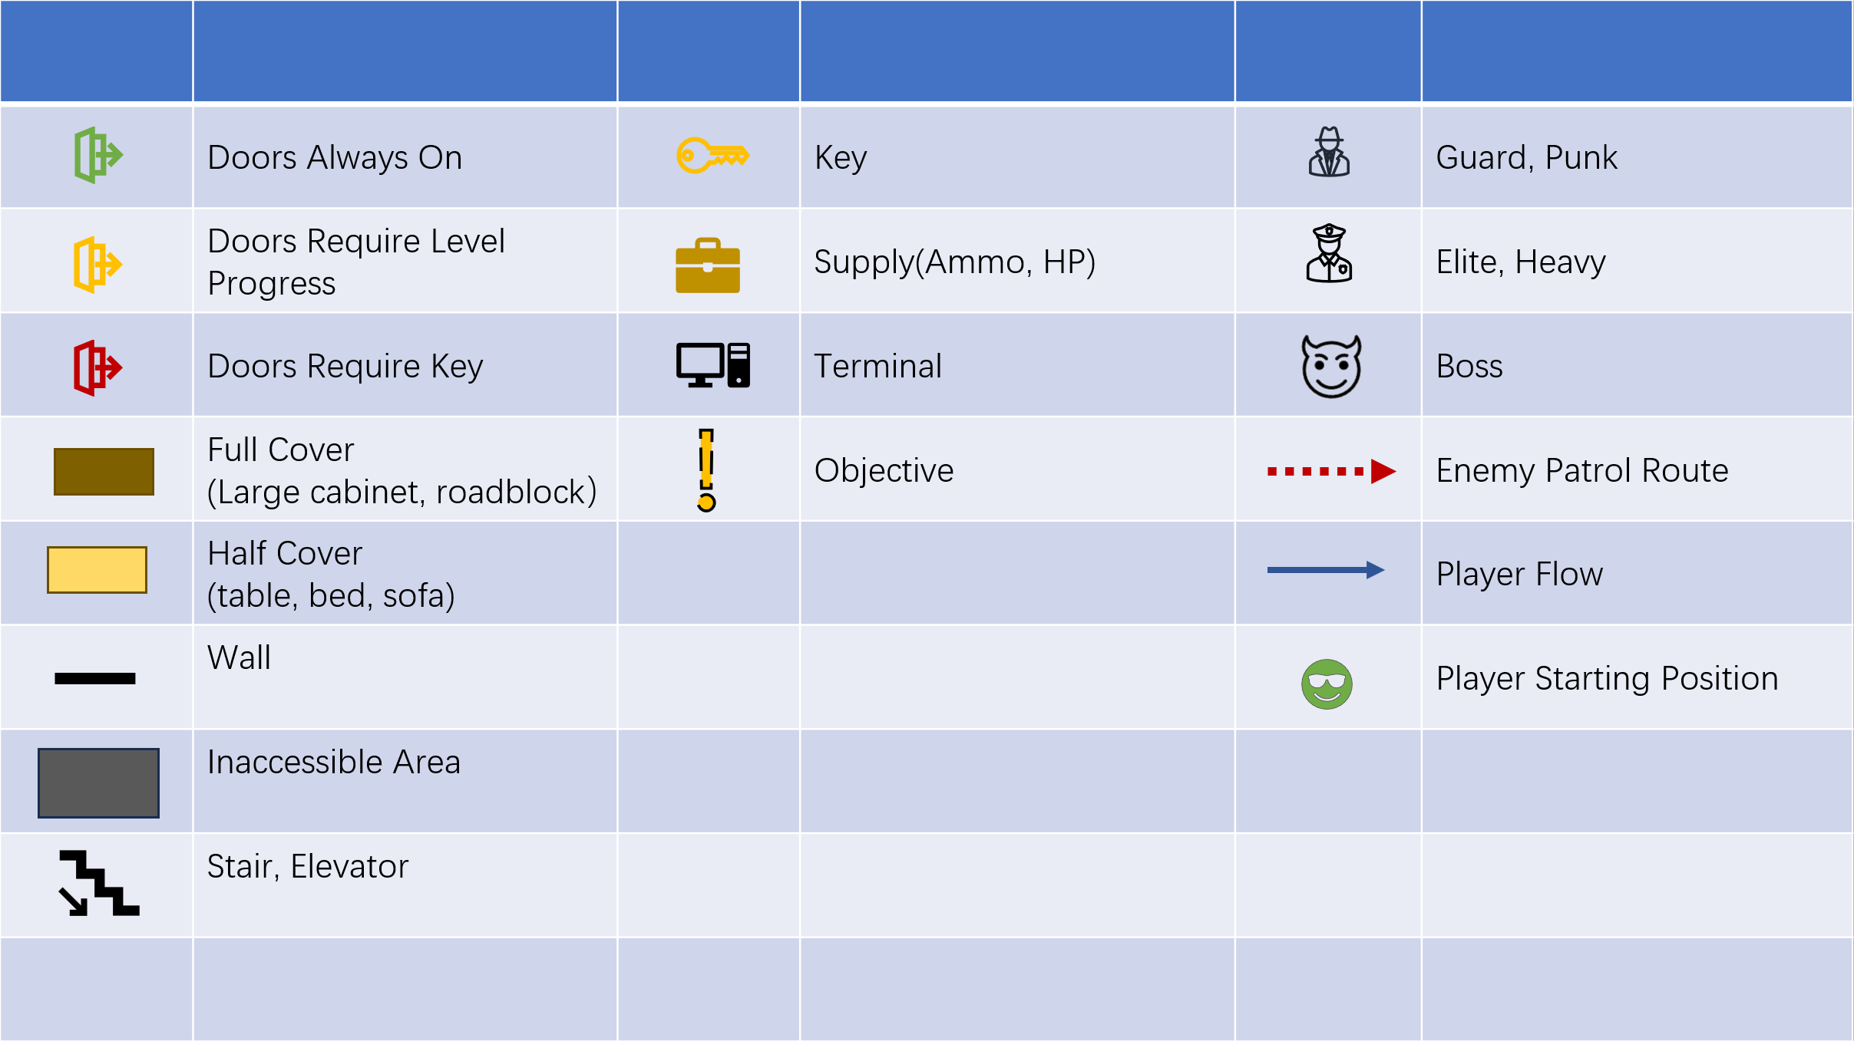

Mansion Rescue-2nd Floor-Game Mode: Raid

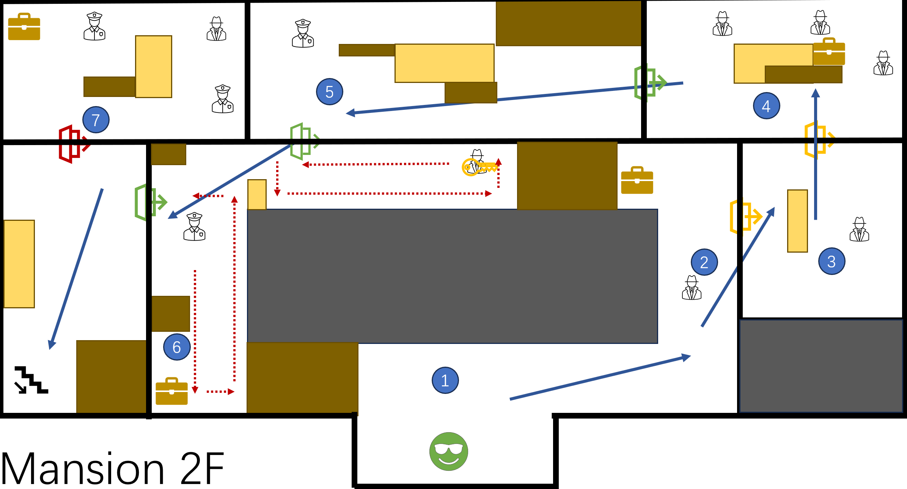

Player enters the mansion from the balcony on the second floor. One side of the hallway is blocked by boxes.

|  |  |  |  |
| --- | --- | --- | --- |
| 1 | A safe room to practice movement | 4 | Combat Practice with 3 regular enemy |
| 2 | Basic Combat introduction: shoot in sync with rhythm | 5 | Elite enemy encountered |
| 3 | Advanced Combat introduction: Blocking | 6 | Find Collectible |
|  |  | 7 | Dynamite practice (WIP) |

Mansion Rescue-1st Floor-Game Mode: Siege

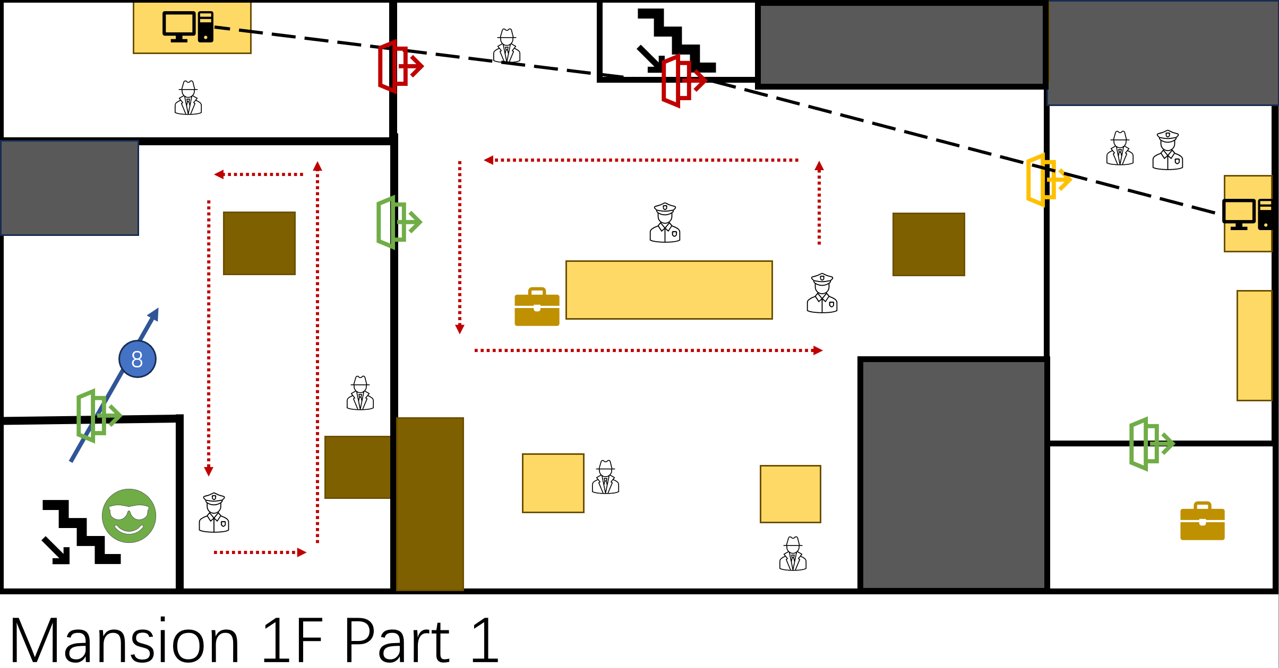

After eliminated all enemies on second floor, player comes down to first floor by the stairs. The lobby at first floor is basically an open space.

|  |  |
| --- | --- |
| 8 | Door is opened, any alarm will attract all the enemies here |

Mansion Rescue-1st Floor-Game Mode: Siege

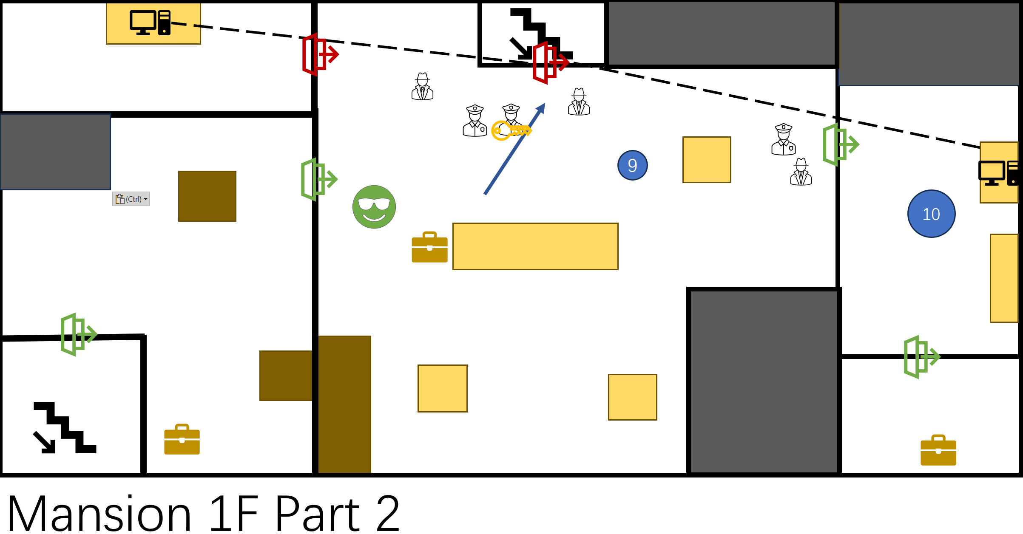

Another squad of enemies will take the center elevator to first floor as soon as all enemy on the first floor is eliminated. Another two enemies will open the door to control room and enter the lobby.

|  |  |  |  |
| --- | --- | --- | --- |
| 9 | Key to Control room 2 is picked up | 10 | Interact with both terminals to activate center elevator |

Mansion Rescue-Basement-Game Mode: Boss

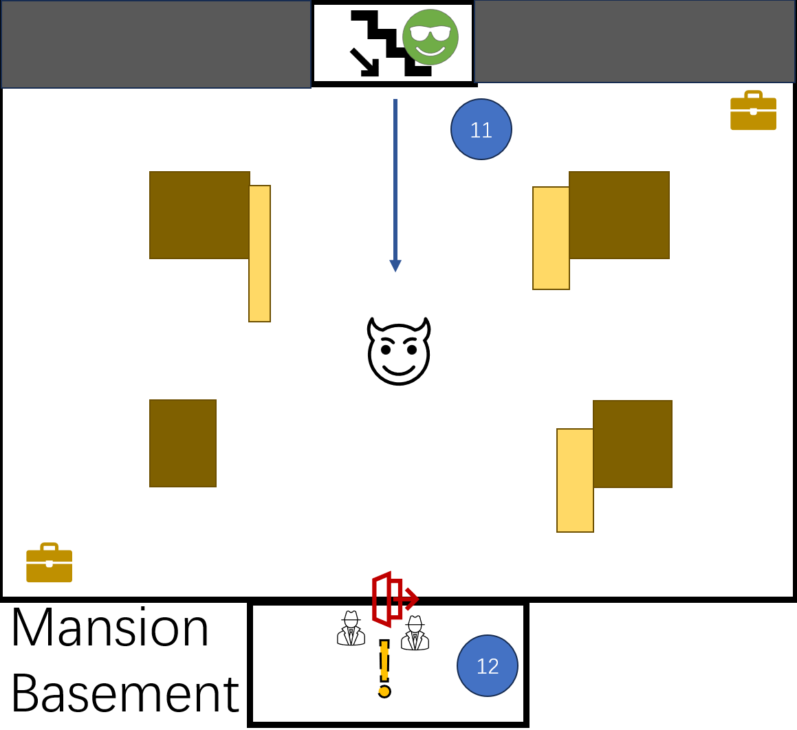

Player enters the basement and encounters the boss, Dual Machine Gun Turret. Teammate will inform player that the weak spot is where the ammunition stored for each machine gun. Player picks up the key and open the cell. Level 1-1 “Mansion Rescue” ends.

|  |  |
| --- | --- |
| 11 | Player encounters the Dual Machine Gun Turret |
| 12 | Player rescues the teammate, level main objective. |

# UI & UX

## Crosshair

Unlike most First Person or Third Person Shooter game, that the crosshair is always in the middle of your screen, top-down shooter game takes you time to find where your crosshair is if it is too small. And it gets more challenging in Timely Shot: while players need to aim at enemies, they also need to pay attention to the rhythm if they want to deal higher damage.

Thus, the core idea of designing the crosshair for Timely Shot can be summarized to one word, CLEAR.

First thing first the aim sight should be clear, which means it can`t be too large which will block your screen, and can`t be too fancy cause it will distract you from aiming; secondly the rhythm indication should be clear, based on the size or color, player should be able to tell if it is a good or bad timing at the moment; and lastly, feedback of the shoot should be clear. Was that a good hit or perfect hit? Did I hit the enemy? Can I shoot through this? In addition to better recognize the rhythm visually, when it is not perfectly on the beat, the highlighted parts are not a complete whole circle, and not as bright as the perfect circle.

|  |  |  |
| --- | --- | --- |
|  |  |  |
| Enemy Hit Miss | Enemy Hit Good | Enemy Hit Perfect |
|  |  |  |
|  |  |  |
| Crosshair On Enemy | Crosshair Not On Enemy | Can`t Shoot Through |

## Other HUD & Menu

Player spends most time focusing on the area around the crosshair during the gameplay of Timely Shot, thus other information might be ignored, for instance: current magazine load. It is not that important cause you know you need to change magazine when you find yourself can`t shoot, but the logic shouldn`t be like this. It should be: you know you can`t shoot when magazine is empty so you change your magazine after you fire the last bullet.

In order not to overwhelm the crosshair and remind player the remaining of current magazine CLEARLY, highlighted bullets, compared to the dark magazines and environment, can be easily spotted with peripheral vision. If there is no yellow or red in the lower right corner of your screen, then the next move will be reloading instead of shooting.

|  |  |  |
| --- | --- | --- |
|  |  |  |
| Pistol Full Mag | Pistol Half Mag | Pistol Empty Mag |
|  |  |  |
|  |  |  |
| Revolver Full Mag | Revolver Half Mag | Revolver Empty Mag |
|  |  |  |
|  |  |  |
| Shotgun Full Mag | Shotgun Half Mag | Shotgun Empty Mag |

As a form of game assistance, player can adjust the volume of beat, music and sound effects.

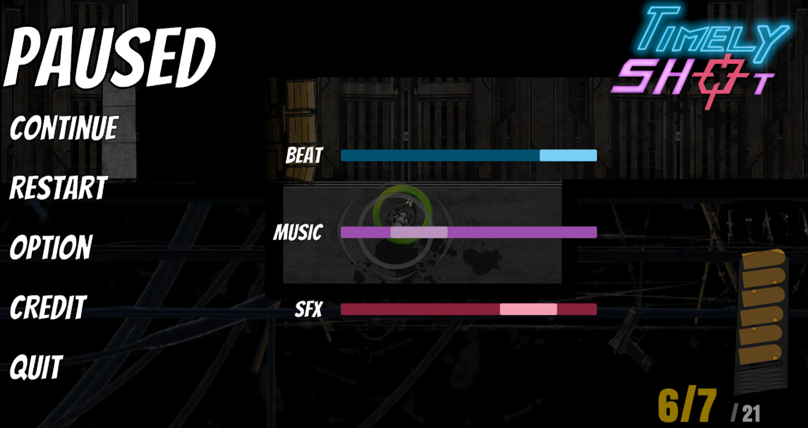

# Art

Note from the character and environment artist, Xinyu Zhang:

“The story begins with tragedy, launching the protagonist on a dangerous path to uncover hidden truths. After witnessing the deaths of his family and loved ones, he becomes outwardly strong but inwardly cold and numb. His inner desolation is mirrored by the gray tones of the game’s world, symbolizing his faded spirit and relentless pursuit of truth. Only in moments of danger does his alertness flare, like a red light in the dark, reminding him to stay vigilant.

In the visual style, I’ve emphasized a mechanical feel to convey the brutal world he inhabits. Harsh metal surfaces, cold mechanical devices, and dark industrial settings combine to create an oppressive and heavy atmosphere, immersing the player in the protagonist’s struggles. Through these visual and emotional designs, I aim to lead players into the depths of the protagonist’s mind, allowing them to feel his loneliness, fear, and determination on his quest for the truth.”

## Characters

### Player

Simple, professional, former trained hitman outfit.

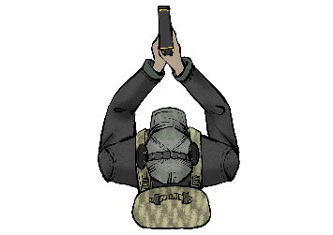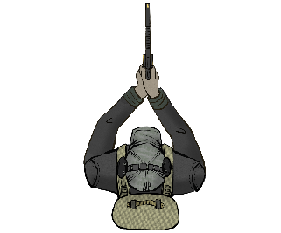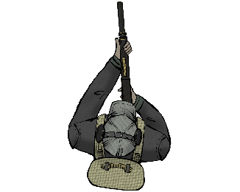

### Enemies

Armor and hat are the main elements to recoganize the enemy types. In order to make enemies more diverse, we applied different hair and hat colors, and different tattos to some of the enemies.

|  |  |  |  |  |
| --- | --- | --- | --- | --- |
|  |  | |  |  |
| Punk A | Punk B | | Guard A | Guard B |
|  |  | |  |  |
|  |  | |  |  |
| Elite A | Elite B | | Heavy |  |
|  | |  | | |
| Dual Machine Guns Turret | | Dual Machine Guns Turret Destroyed | | |

## Environment

The setting of this level is an almost abandoned Mansion taken by a gang and transformed to a temporary cell. While some furnitures remain the same, others are replaced by military gears or moved to corner. Spider webs and stains can be spotted everywhere.

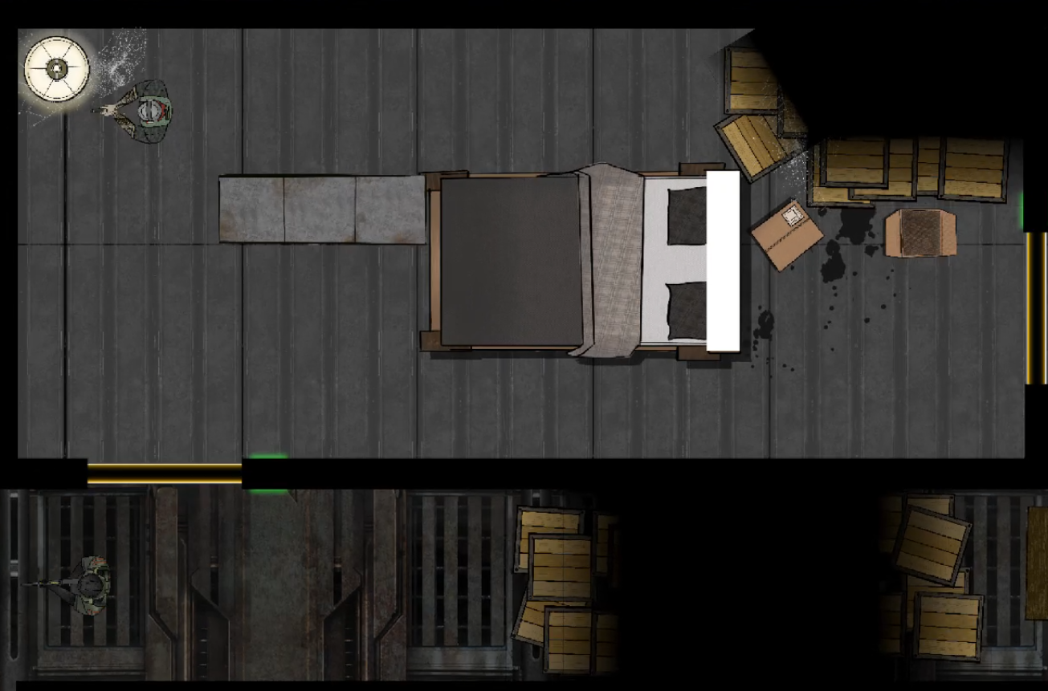

Bedroom, 2nd Floor.

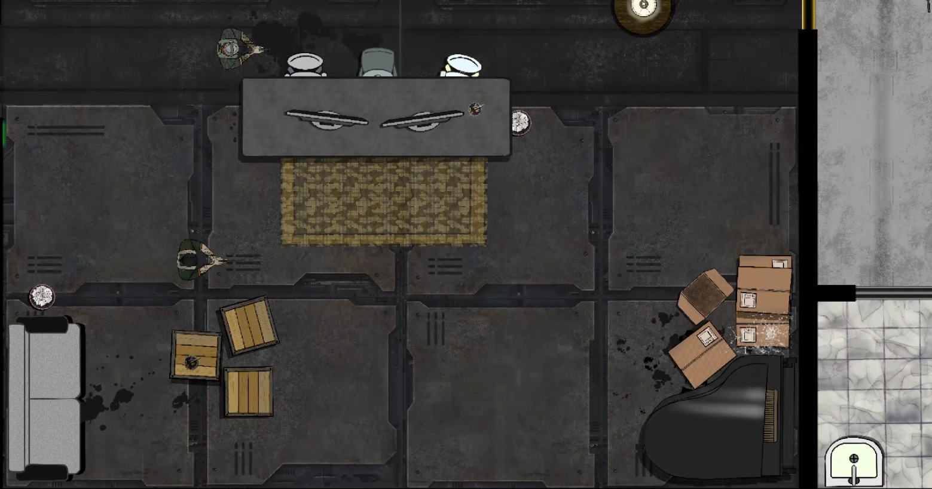

Main Lobby, Ground Floor.

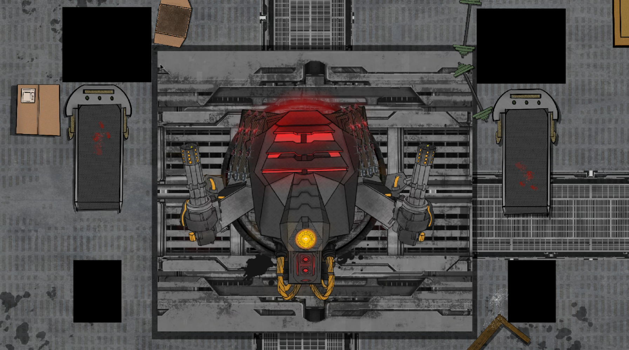

Dual Machine Guns Turret, Basement

# Audio

## Music

Message from the sound engineer , designer and composer, Shangshu (Mint) Shi:

“Doing sound and music for Yu’s work is always a “yes” and a “yes?” on my side.

The yes part comes from the fact that, he is a brilliant game designer, and a terrific producer, and a genius story teller. He knows the importance of all the humanistic ideas to a game and he is willing to find every way to convey those ideas into an interactive form, which we called as game. Why would there be a question mark as well? Because I am always asking myself, if I have the capability to bring out new materials and distinct sonic quality to fit, and even highlight what he brings to the table.

The story itself is, in one word, punctuating. The main character finds himself in a cyberpunk-sequel world, it’s rain, it’s metallic walls and floor, it’s his family and love dying in front of him and he has to find the truth and survive from all the most brutal and vicious challenge in front of him. Every shot and every hit he makes and takes is like a heavy punch, and you have to make every part of that punch count.

And I think, sonically, that was the end result I made to the game. The entire game, can be sonically transformed on its own, as someone who tries to punch and fight all the obstacles, in the most depressing and breath-less atmosphere, trying to find his way out, find his way through.”

## Sound Effect

During the process of sound designing, due to the 12 hours of time difference we have, Mint and I communicate through this sheet which is extemely helpful and organized for both of us.



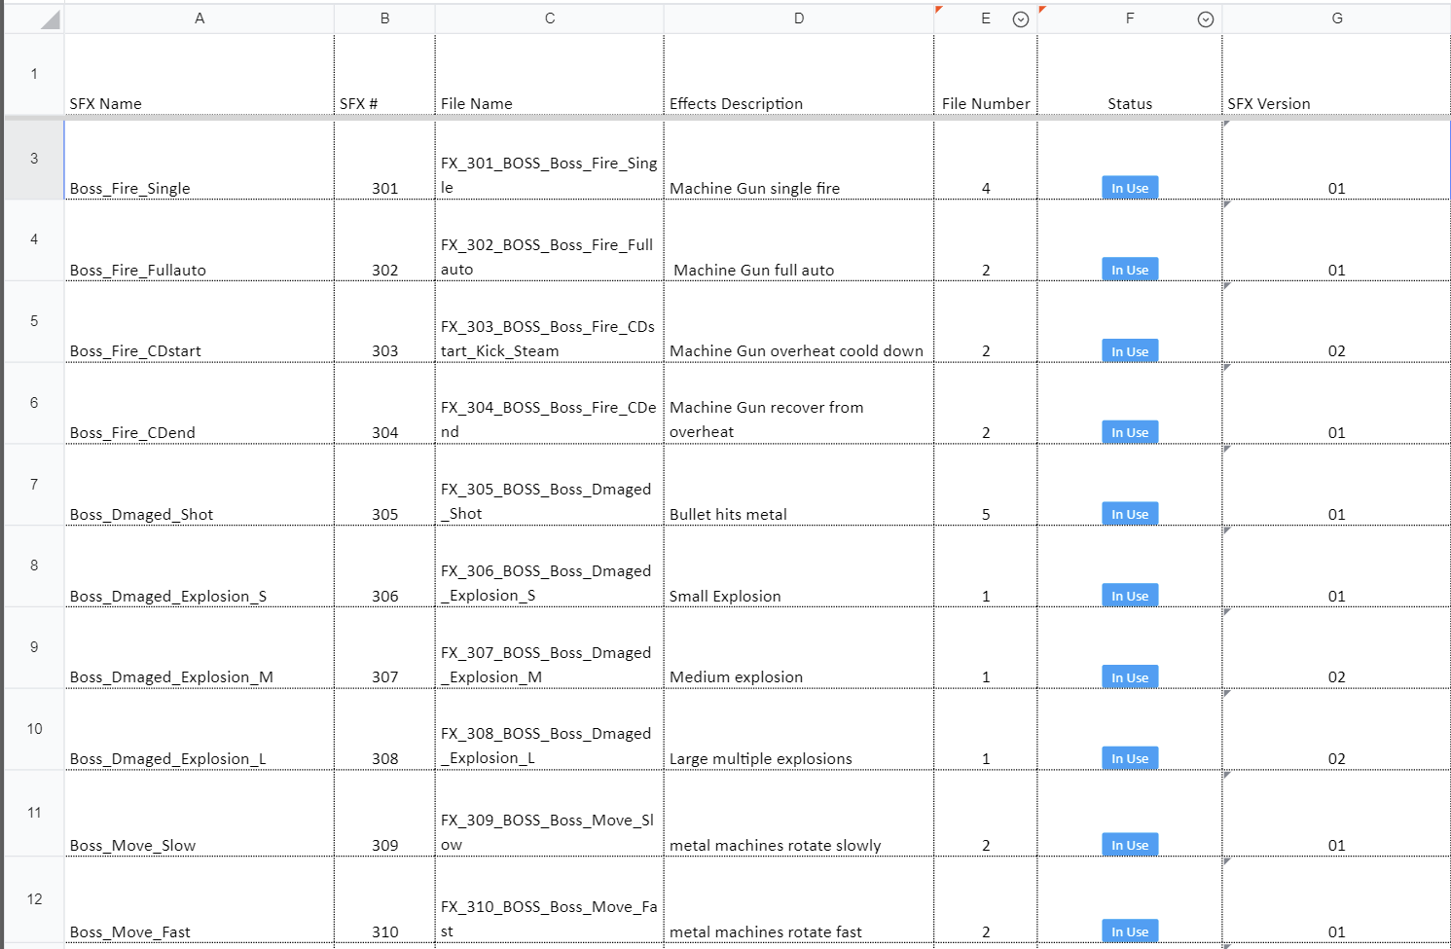

# Future Plan

When I first wrote this story and set the protagonist J's birth year to 2027, I was thinking that by 2027, I would have graduated with an master`s degree in Game Design and Development, and by then, Timely Shot would be almost complete, polished, and ready for release. In the next three years, I will continue refining the designs, learning and practicing game programming, working in my spare time, and actively seeking collaboration to complete this, main storyline lasts 3-4 hours rhythm shooter game, Timely Shot.

## Full Game Level Timeline

## Game Modes

Other than Raid, Siege, and Boss, the three modes presented in Mansion Rescue, the following modes are in consideration for narrative and gameplay.

|  |  |
| --- | --- |
| **Modes** | **Description** |
| **Memory** | Player follows the guidance to interact with environment and proceed. |
| **Training** | Automatically unlocked once Mansion Rescue is finished. Training range is located in Operation Base. |
| **Bounty Hunt** | Unlock in Chapter 2. Player first needs to retrieve 1 to 3 clues to find the right targe, then can go and eliminate the target in a **Raid**, **Siege** or **Boss** map. |
| **Endless** | Unlock in Chapter 3, player can choose any **Siege** map from past levels to start an Endless game. |
| **Hardcore** | Unlock after 10 side objectives are completed. Player can choose from offered challenges to finish any past levels to earn extra reward and a place on the ranking board: faster rhythm, faded crosshair, and 1 life. |

## Player Abilities

Player may unlock more active and passive abilities by level progress, side objectives completion and item collection.

|  |  |  |  |  |
| --- | --- | --- | --- | --- |
| **Name** | **Unlock** | **Cost** | **CD** | **Description** |
| Advanced  Prosthesis | Finish Chapter 1 and complete 18+ side objectives | 10K | 25s | Automatically block all the bullets fired at player in the next 3 seconds.  Triggered with Perfect hit will reduce the cooldown by 20%. |
| Extra Armor | Unlock at beginning | 3K | 15s | Gain 5 temporary health, last 3 seconds.  Triggered with Perfect hit will grant 2 more health and last 2 more seconds. |
| Kinetic Absorption | Unlock at beginning | 1K | NA | Kinetic Absorption grant player a 30% chance of recycling the bullet blocked by player.  Triggered with Perfect hit will increase the chance to 50% |
| Rhythm Master | Complete 9+ side objectives | 6K | 20s | The next 5 bullets will deal the damage of Perfect hit.  Triggered with Perfect hit will grant 3 more bullets |
| Gadget Master | At the beginning of Chapter 2 | 10K | 30s | Regain 1 gadget.  Triggered with Perfect hit to regain 2 gadgets |
|  | Complete 27+ side objectives. | 20K | 60s | Fire rate, movement speed of enemies within 40 feet reduced by 50% in the next 5 seconds.  Triggered with Perfect hit will reduce the cooldown by 20% |

# Appendixes

## Earliest Test Demo

The first time we tested the function of shooting along with rhythm in August.

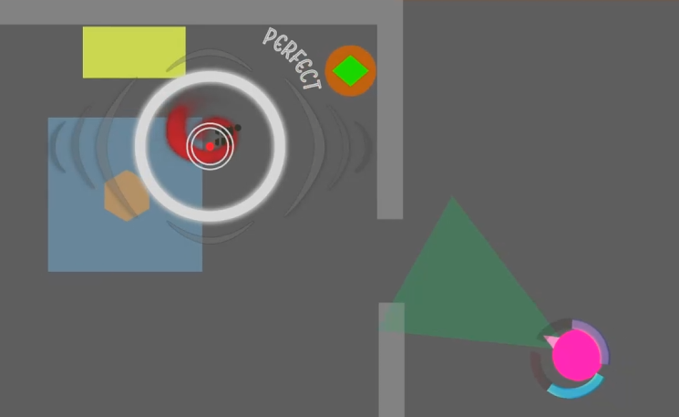 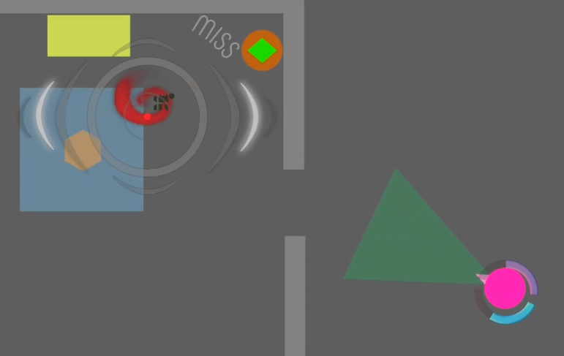

## Archived One Page Design And Title

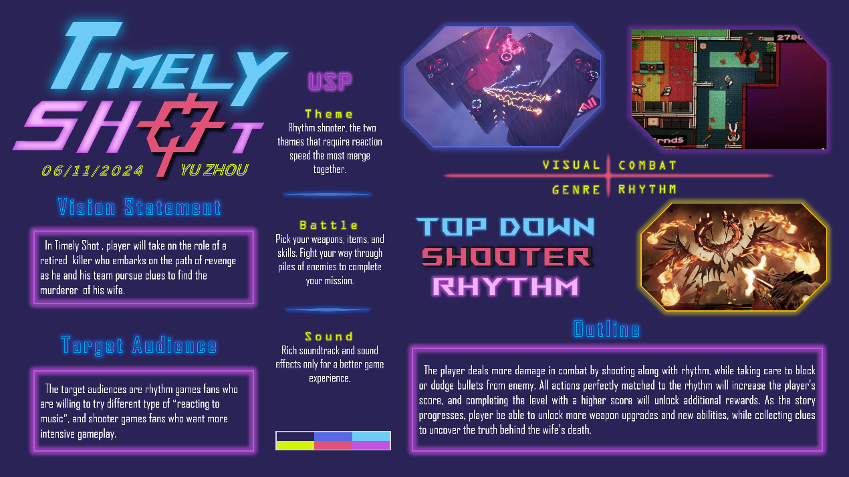

Before Xinyu Zhang joined the project as artist in September, I had a different vision on the visual aspect of Timely Shot: Cyber, Neon. The first thing we discussed was the story and theme. Based on the general storyline, and her expertise, we eventually go with today`s more realistc, mechanical, and depressed art style.